42.11: Energy levels are 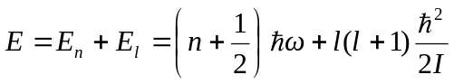
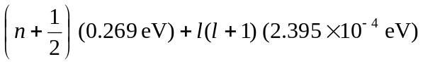where the values are from Examples 42.2 and 42.3.
a) 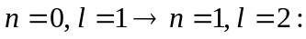
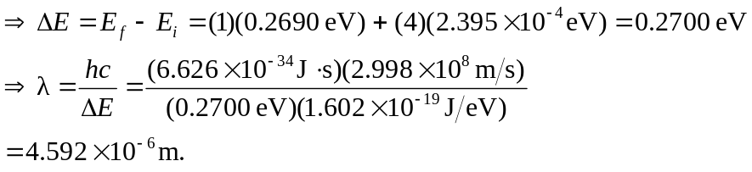
b) 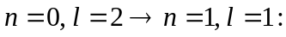
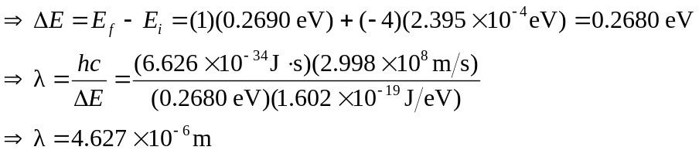

c) 